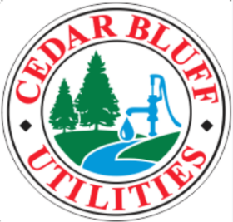

The Utilities Board of the Town of Cedar Bluff
P.O. Box 306 Cedar Bluff, AL 35959
Phone: (256) 779-6359
Fax: (256) 779-7299
e-mail: lstowe@cedarbluffutilities.com

I ___________________________certify that I will have _ ____ family dwelling, one farm dwelling with appurtenances, one camper per recreational lot, and/or one commercial business per water meter and/or sewer tap.

As of December 18, 2018, multi-user hook ups of water or sewer will not be allowed. Single use only! Any additional hook ups found will result in an immediate disconnection of service. Reconnection fee will be applied.

Service Address:

_______________________________________________________________________

I also acknowledge receipt of a copy of the policies and procedures of The Utilities of the Town of Cedar Bluff and agree to abide by same.

_____________________________ __________________________
Customer Date

_____________________________
Witness

