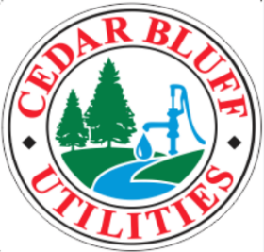

The Utilities Board of the Town of Cedar Bluff
P.O. Box 306 Cedar Bluff, AL 35959
Phone: (256) 779-6359
Fax: (256) 779-7299
e-mail: jbolton@cedarbluffutilities.com

AUTHORIZATION AGREEMENT FOR PRE-AUTHORIZED PAYMENTS
(ACH DEBITS)

I authorize the above named, Cedar Bluff Utility Board to initiate entries to the account indicated below as follows:

- They may initiate DEBIT entries, which removes money from my account, for payments I owe, according to the schedule and other conditions to which the Cedar Bluff Utility Board and I have agreed.
- They may initiate CREDIT entries to reverse any transactions they have originated to my account in error.

Name(s): _______________________________________________________________
(please print)

Checking Account Number: ________________________________________________

Name of Depository Financial Institution: _____________________________________

Location of Depository Financial Institution: ___________________________________

City: ______________________State: ____________________Zip: ________________

Please enter your bank’s routing and transit number below. *

___ ___ ___ ___ ___ ___ ___ ___ ___ (nine digits)

This authority is to remain in effect until The Utilities Board of the Town of Cedar Bluff has received written notification of its termination and has had a reasonable opportunity to act upon it.

Signed: _________________________________________________________________

Date: ___________________________________________________________________

*DO NOT USE A DEPOSIT SLIP. Many banks print internal transaction codes instead of their routing and transit numbers on their deposit slips. Using an invalid routing and resulting in delays in the posting of your payment. Must have a VOIDED CHECK!!!

